**DBMS Lab Assignment 10**

**Neeti Kurulkar**

**Aggregate Operations using MongoDB**

**Queries:**

1. **Create Collection**





1. **Insert Values**

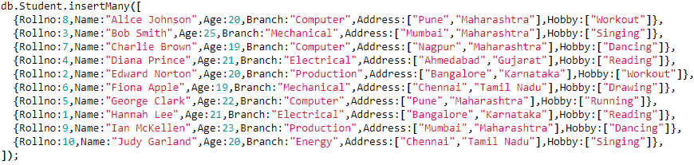

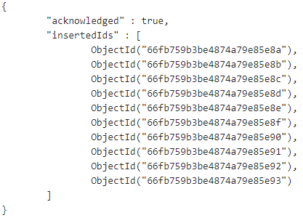

1. **Display values**



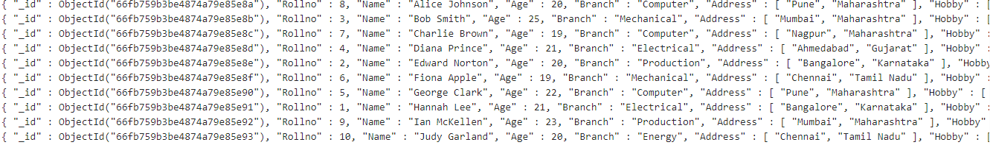

1. **Grouping by branch and finding min, max, first and last**

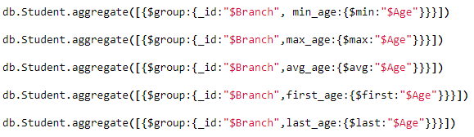

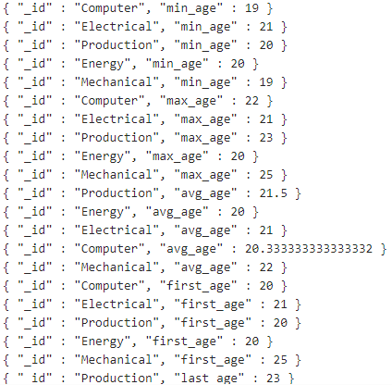

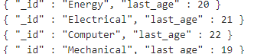

1. **Sorting in ascending and descending order**



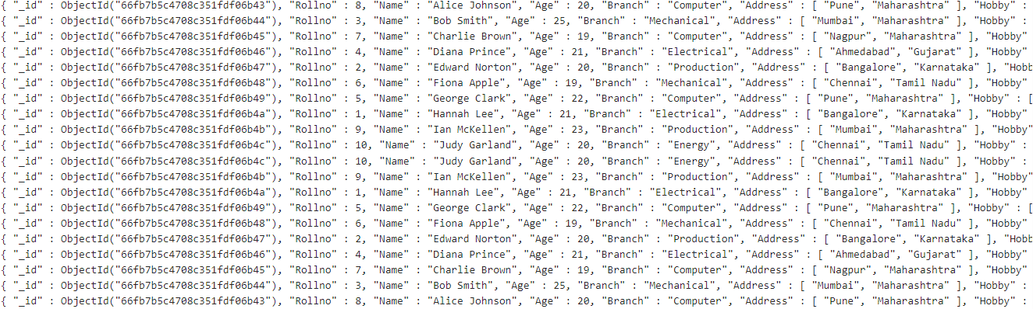

1. **Displaying according to branch**





1. **Creating Index**



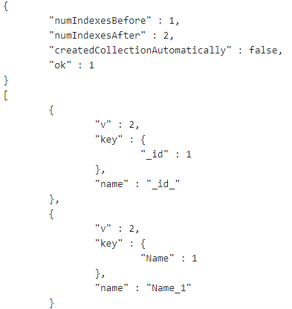

1. **Dropping Index**



